C0544 - Close Opportunity as Won when linked Sales Contract is set to Awarded

|  |  |  |  |  |
| --- | --- | --- | --- | --- |
| **Ver** | **Date** | **Author** | **Comments** | **Reviewed by** |
| 1 | 01/03/2020 | Tom Bell | CRIM 0544 - CRM | TBC |
|  |  |  |  |  |

Requirements 2

Prerequisites 2

Solution Overview 2

Solution Details 2

Security 3

Companies 3

Data Migration 3

Test Steps 3

Technical Implementation 3

Requirements

Close the linked Business Opportunity as Won when the linked Sales Contract is set to Status Awarded.

Prerequisites

<Describe any pre-requisites that this development may rely upon, data configuration or other developments>

Solution Overview

When a Sales Contract linked to a Business Opportunity has been set to status Awarded, the linked Business Opportunity must be set to Closed with Closed Status Won.

Currently, the system only changes the Business Opportunity, Opportunity Line as Won, while not closing the whole Opportunity.

Solution Details

When a Sales Contract linked to a Business Opportunity has been set to status Awarded, the Business Opportunity must be set to Closed with Closed Status Won.

The below screenshot shows that the Sales Contract has been Won, see red box on right hand screen. The screen on the left shows that the Opp Line has changed to Status Won (in blue box).

However, the Status of the Business Opportunity header (red box left screen) must be closed as Won. Once the Sales Contract has been Awarded the Business Opportunity must change to Closed, with Closed Status WON, with the reason “110” “Sales Contract Won”.

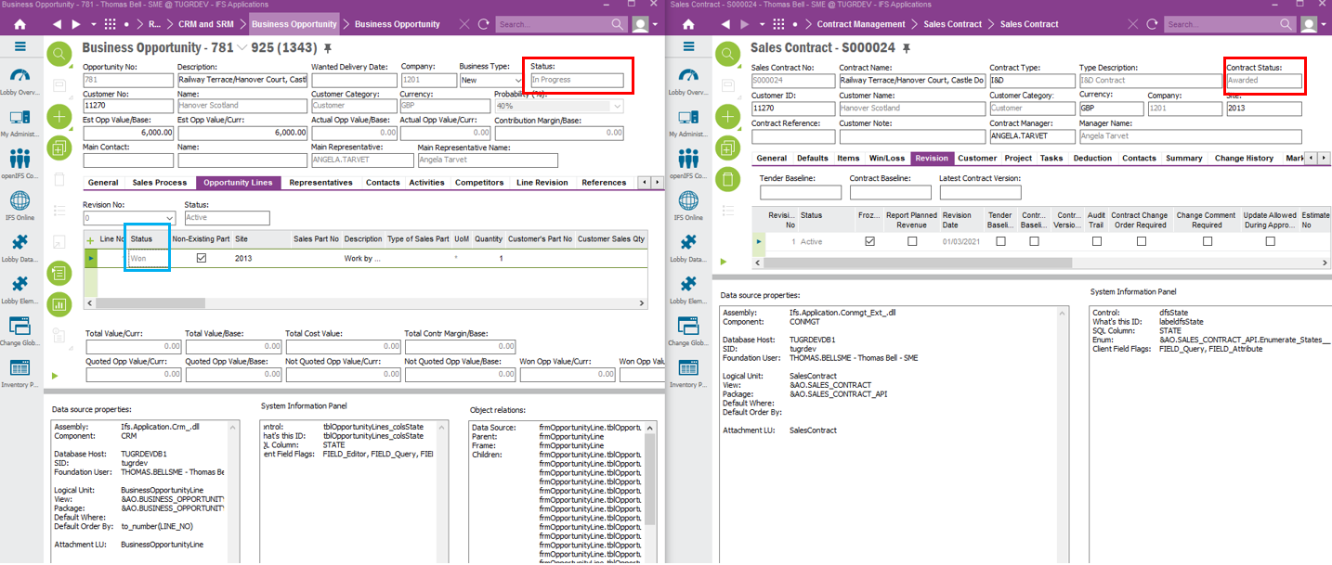

**Technical.**

Field Definitions.

<New Field/CLU Definition>

|  |  |  |  |  |  |  |
| --- | --- | --- | --- | --- | --- | --- |
| New DB Object Name | DB Object Item/Field Names | Item Description | Item Data Type | Item Syntax | Calculation Spec, if Derived | LOVs/Enums/Is Mandatory? |
|  |  |  |  |  |  |  |
|  |  |  |  |  |  |  |
|  |  |  |  |  |  |  |
|  |  |  |  |  |  |  |
|  |  |  |  |  |  |  |
|  |  |  |  |  |  |  |
|  |  |  |  |  |  |  |
|  |  |  |  |  |  |  |
|  |  |  |  |  |  |  |
|  |  |  |  |  |  |  |
|  |  |  |  |  |  |  |
|  |  |  |  |  |  |  |

Security

<Define security controls> (Who needs access to this and will it be restricted from any other users etc)

Companies

Applies to the following companies. All.

|  |  |
| --- | --- |
| **Company** | **Required (Y/N)** |
| 1201 | Y |
| TBC |  |
|  |  |

Data Migration

<Describe any data migration impacts this development may have – i.e additional data to be migrated>

Test Steps

<Steps that needs to be taken to test this change. Please provide expected results> Updated post solution.

|  |  |  |
| --- | --- | --- |
| **No** | **Script\Test Steps** | **Expected Result** |
|  | When a Sales Contract linked a Business Opp is set to won | The Business Opp is set to status Closed as Won |
|  |  |  |

Technical Implementation

This implementation uses following custom objects;  
  
Custom Event: CLOSE_BUS_OPPORTUNITY  
  
